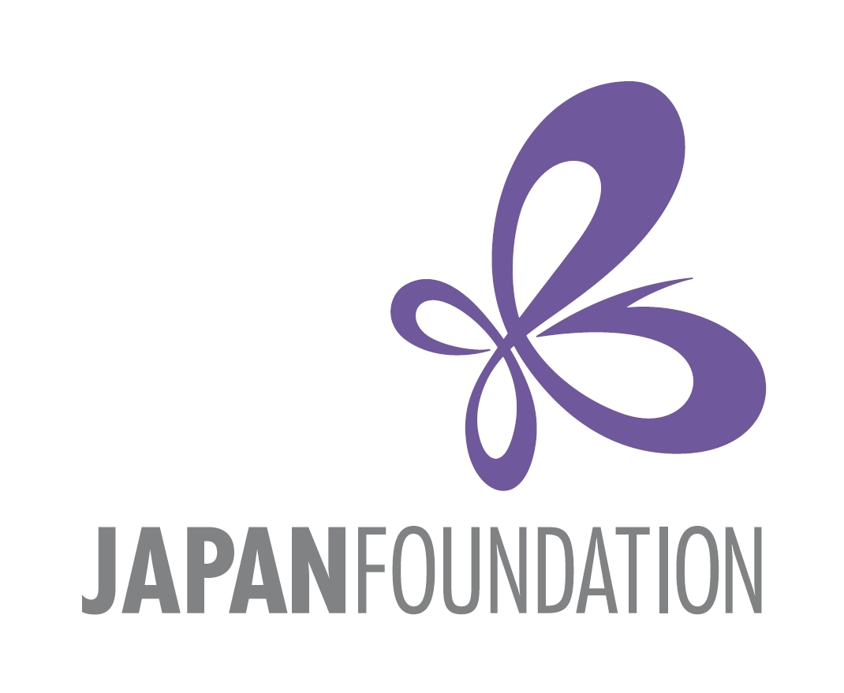

PhD Workshop for Doctoral Students in Japanese Studies in Central and Eastern Europe 2022

Call for Participants

Application Deadline: 1st December, 2021

The Japan Foundation, Budapest (JFBP) would like to invite you to submit an application to participate in the Japanese Study Workshop scheduled for 5-6th February, 2022. The official language of the seminar will be English, and this year the Workshop will take place online

The aim of this workshop is to offer a unique opportunity for participants to work together intensively to enhance individual projects and engage in concentrated discussions of common themes and methods. Through presentations and focused sessions, students give and receive critical feedback on thesis projects, fieldwork plans and preliminary results.

The informal environment of the workshop provides doctoral students an opportunity to create a multidisciplinary network of advanced graduate students and senior scholars in Central and Eastern Europe in the field of Japanese Studies.

Through a two-day long intensive workshop, students will be asked to read the work of their peers, comment on the work of each other, and prepare for workshop presentations linking their own work to the broader international Japanese studies field.

We are calling for applications from advanced graduate students who are pursuing PhD degrees in the region. Those who are embarking upon or in the process of writing their PhD dissertations are eligible. Their area of expertise can be in all humanities and social science disciplines (except for Japanese language education), e.g. in politics, history, society, pop culture, literature, arts, language, thought, religion, etc.
About 10 participants will be selected to make an approximately 15-minute long presentation on their research and engage in discussions in English.
Participant students will be supervised by designated senior scholars through the workshop.

§ Eligibility
The following applicants are eligible:
- Full-time graduate students researching fields related to Japanology, regardless of citizenship, who are enrolled at universities in the Central Eastern European region (13 countries, including Bosnia and Herzegovina, Bulgaria, Croatia, Czech, Hungary, Kosovo, North Macedonia , Montenegro, Poland, Romania, Serbia, Slovakia, and Slovenia).
- Students originally from the Central Eastern European region (with nationality of the fore-mentioned 13 countries), who are enrolled in graduate programs outside of the region, but who have a research field related to Japanese Studies.
- Applications are particularly welcome from graduate students in the early-fieldwork through the middle stages of thesis writing.
- Applicants who participated in JFBP’s PhD workshop or seminar in 2018 and 2020 are eligible if they intend to make different presentations based on their latest research results for this occasion.
- Although the official language of the workshop is English, all applicants are expected to have studied the Japanese language.

§ Application and selection procedures
1. Prior to the workshop, all participants are expected to submit the following as part of their application. All materials should be sent via e-mail to tothtimea@japanalapitvany.hu no later than Wednesday, 1st December, 2021.

1) A covering letter (no more than one page), indicating the motivation for attending the workshop as well as the current state of progress of doctoral work.
2) A summary of the dissertation project (450-500 words).
3) A brief professional history (CV), including a list of publications, if any.
- One reference letter by a senior scholar of your choice.
2. Applicants will be notified of the selection results by Wednesday, 8th December, 2021.
3. Following the results of the selection, participants will be requested to submit an essay by Wednesday, December 22nd, 2021. The essay should be a project outline and progress report of the doctoral research (ca. 1500 words) containing major research questions, structure, sources, methodology, difficulties, if any, etc., or a long essay (3000-3500 words) i.e. any (preliminary) part of the thesis, for example theoretical introduction, research review, data analysis, elaboration of specific questions, and/or arguments etc. The essay should conform to best academic practice (language, referencing, etc.)
This will be edited and compiled afterword for publication, scheduled in 2023.
Senior scholars from the Central and Eastern European region will be participating and be actively involved in discussions during the workshop. JFBP will seek their advice upon selecting the participants.

§ Inquiries
For further information about the workshop or eligibility, please contact Tóth Tímea, Assistant of the Directors, The Japan Foundation, Budapest at tothtimea@japanalapitvany.hu or call +36-1-214-0775.

Thank you for your interest. We look forward to hearing from you!

